Analysis document
Revision history
Date | Version | Description | Author
2016-04-18 | 1.4 | Adding missing requirements and intro | Seldin Music
2016-04-19 | 1.5 | Modifying requirements | Seldin Music
2016-04-24 | 1.5.1 | Minor tweaks | Seldin Music
2016-05-01 | 1.6 | Add interface image | Xingchen Lu

Products List: We will be selling boxed movies to our devoted fans who still appreciates to have a physical product rather then digital one. The main purpose of the this project is to establish a well-designed web store where a customer can visit and order a movie.
The customer will not be required to create an account in order to make orders. The customer will be able to brows our items by searching by category, searching for a specific movie or just see all available movies. Once a movie has been selected more information related to that movie will be shown and at this point the customer will be able to add that movie to the shopping basket. When the customer is ready to make the order the shopping basket icon will be the place to proceed. Once in the shopping basket the customer will be able tho change quantity of the selected movies or remove any movies. Customer will have to submit some contact information to proceed with the order. Once the order has been completed an order number will be displayed and an email will be sent out to the customer with related information. The customer will be able to lock up there order by submitting the order number on selecting orders icon.
The admin will need to log in to gain access to the administrative system of the web shop. Once logged in the admin will be able to manage other admin accounts, manage orders and manage movies. Once admin icon has been selected one will be able to see all active admin accounts. Once one has been selected password will be able to to change and ability to remove an account. Once orders has been selected there will be a possibility to change some contact information a related to the selected order and changing the order status of the order. Once movies has been selected, the ability to modify a specific movie. There will also be possible to add a new movie and remove an existing movie.

Note the letter a behind the ID tag stands for anchored. It means it has been anchored to the deliveries document.

General requirements:
ID | Requirements
1.3a | The web shop will contain any number of items.
1.4a | All information relating the movies will be store in a database.
1.5a | Every movie will have a title.
1.6a | Every movie will belong to at least one category.
1.7a | Every movie will have quantity, to see if movie is in stock.
1.8a | Every movie will have a price.
1.9a | Every movie will have a description.
1.10a | Every movie will have an image.

Customer mode requirements:
ID | Requirements
2.1a | The web shops logo will be present at all time at the top left corner. It will act as the main way to return to the main homepage.
2.2a | A search box will be present at all times on the top of the web shop.
2.3a | The customer will be able to search for a move by typing it's name.
2.4a | The customer will be able to see all movies for sale by pressing all movies icon.
2.5a | The customer will be able to search movies by category by clicking on icons with category names.
2.6a | Once a movie has been selected, title, category, quantity, price, description and description will be shown.
2.7a | Customers will be able to view shopping basket.
2.8a | Customers will be able to look up there order status.
2.9a | Customers will be able to brows around the web shop.
2.10a | The customer will be able to add a movie to the shopping basket.
2.11a | The customer shall be able to view the selected movies in the shopping Basket.
2.12a | It will be possible to change the quantity of the selected movies in the shopping Basket.
2.13a | It will be possible to remove movies from shopping basket
2.14a | The final price will be updated on modifying any item's in the shopping basket.
2.15a | The customer must fill in his/her contact information to finalize the purchase.
2.16a | The customer will receive an order number after confirming the purchase.
2.17a | The customer will be able to use the received order number on clicking the orders icon.
2.18a | Once order number has been submitted it will show the order information. First and last name, email, phone number will be blurred out.

Administrator mode requirements:
ID | Requirements
3.1a | The admin must authenticate to gain access to the administrative system.
3.2a | The authentication must be done by providing a valid user name and password.
3.3a | Admin accounts and passwords will be stored in a database.
3.4a | Once the admin has been logged in the admin tool set will be shown.
3.5a | When a customer places an order, the order will be added to the database and the quantity of the ordered products will be updated in the web shop.
3.6a | In the Admin system it will be possible to add a new movie.
3.7a | In the Admin system it will be possible to remove a movie.
3.8a | In the Admin system it will be possible to change information about a movie.
3.9a | In the Admin system it will be possible to manage deliveries (i.e. update the quantity of items).
3.10a | In the Admin system it will be possible to add a new administrator account.
3.11a | In the Admin system it will be possible to remove an administrator account.
3.12a | In the Admin system it will be possible to add a new product category.
3.13a | In the Admin system it will be possible to view all orders.
3.14a | In the Admin system it will be possible to update an order.
3.15a | Each order will have a status: New, Delayed or Shipped.
3.16a | The admin will be able to update the order status manually.
3.17a | Admin will have same search functionality as customer.
3.18a | Change contact information(in case customer need to change an order). All field has to be filled to commit the update.
3.19a | Remove or update quantity of one movie.
3.20a | After an update of movie has been made the price needs to be updated.

Non functional requirements
ID | Requirements
4.1 | The web shop is going to respond within a maximum of 3 seconds.
4.2 | Security will be held up by the admin authentication and data validation.
4.3 | The web shop web application will be testable.
4.4 | All documentation will have revision information.
4.5 | The user will receive some kind of error message if some process goes not as intended.
4.6 | Reliability will be enforced by testing the code.
4.7 | The customer should be able to add movies and remove items from the shopping basket without getting confused.
4.8 | Making an order should not take more then 5 clicks.
4.9 | Looking up an order number should be informative.
4.10 | The web shop will have a unified look and feel.

Use case Diagram

User case Description
1. Movies
1.1 Search movies
Actor: customer and admin
Task: Search for any movie available in the system.
Comments: A user should get any movie he/she searches on the search bar by a name. If a movie is not in stock, it can also be found.
Customers: Admins:
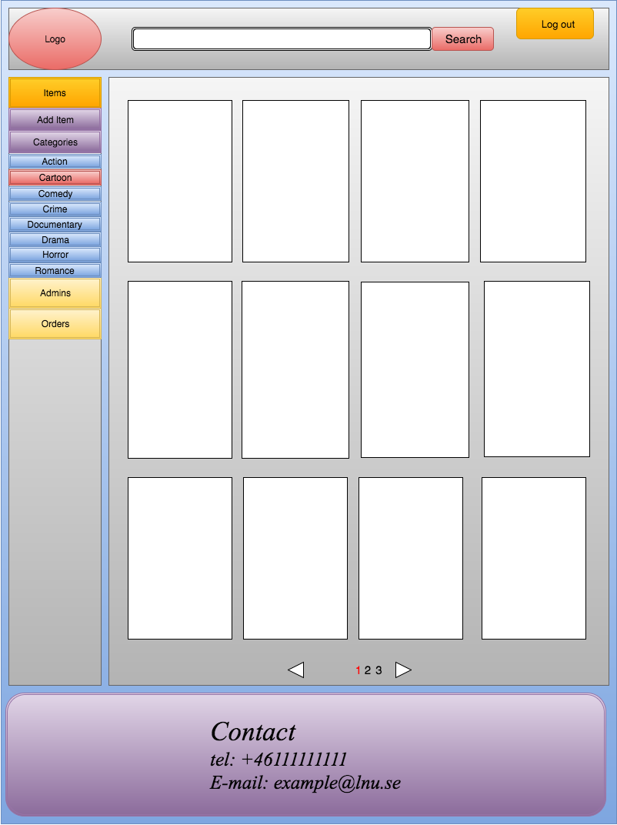

1.2. Movie details
Actor: Customer and admin
Task: See movie details and edit.
Comments: Customers can only see the details and add it to the basket. Admins can see and edit details by an edit mode button.
Customers: Admins:

2. Basket
Actor: Customers
Task: Customers can add movie, delete movie, edit quantity, edit delivery address, contact information and make order in the basket.
Comments: The basket will show all details of the future order show in the image below. If the customer change any item’s details, refresh the page. If the contact info is not completed and the customer press the make order button, there will be a warning, and the page will not change.

3. Orders
Actor: Customers and Admin
Task: View orders, orders detail, change order status.
Comments: Customers can only view orders, they cannot change any details in a numbered order, and the middle part of the addresses information is hide. Admin can see completed information, and change addresses information and order status. The quantity cannot be change. Items cannot be delete. The price cannot be change.
Customers: Admins:

4. Accounts
Actor: Admin
Task: Add, delete, edit admin accounts.
Comments: If an admin press delete for another admin, the first admin should put in the password of the second admin. (we are not decide whether there is a master admin or not.)
Accounts: Edit/add accounts:

